Progressive Education Society's

**Modern College of Engineering, Pune**

**MCA Department**

**A.Y.2023-24**

**(410908) : Data Science Laboratory**

********************************************************************************************* Class: SY-MCA Shift / Div : B (S1) Roll Number : 52119

Name: Harsh Ghodke Assignment No: 5 Date of Implementation: 09/10/2024 *********************************************************************************************

**Q.1) Find the mean, median, Mode, Range, Interquartile Range IQR and normal distribution**

**of the physical-fitness scores. Third graders at Roth Elementary School were given a physical-fitness test. Their scores were:**

**a. 12 22 6 9 2 9 5 9 3 5 16 1 22 18**

**b. 6 12 21 23 9 10 24 21 17 11 18 19 17 5**

**c. 14 16 19 19 18 3 4 21 16 20 15 14 17 4**

**d. 5 22 12 15 18 20 8 10 13 20 6 9 2 17**

**e. 15 9 4 15 14 19 3 24**

**Answer:-**

# Defining the scores for each group

group_a <- c(12, 22, 6, 9, 2, 9, 5, 9, 3, 5, 16, 1, 22, 18)

group_b <- c(6, 12, 21, 23, 9, 10, 24, 21, 17, 11, 18, 19, 17, 5)

group_c <- c(14, 16, 19, 19, 18, 3, 4, 21, 16, 20, 15, 14, 17, 4)

group_d <- c(5, 22, 12, 15, 18, 20, 8, 10, 13, 20, 6, 9, 2, 17)

group_e <- c(15, 9, 4, 15, 14, 19, 3, 24)

# Function to calculate mean, median, mode, range, IQR

calculate_stats <- function(scores) {

mean_value <- mean(scores)

median_value <- median(scores)

mode_value <- as.numeric(names(sort(table(scores), decreasing = TRUE))[1])

range_value <- range(scores)

iqr_value <- IQR(scores)

return(list(

Mean = mean_value,

Median = median_value,

Mode = mode_value,

Range = range_value,

IQR = iqr_value

))

}

# Calculating stats for each group

stats_a <- calculate_stats(group_a)

stats_b <- calculate_stats(group_b)

stats_c <- calculate_stats(group_c)

stats_d <- calculate_stats(group_d)

stats_e <- calculate_stats(group_e)

# Displaying the results

print("Group A stats:")

print(stats_a)

print("Group B stats:")

print(stats_b)

print("Group C stats:")

print(stats_c)

print("Group D stats:")

print(stats_d)

print("Group E stats:")

print(stats_e)

# Plotting normal distribution for one group (for example, group A)

group_a_mean <- mean(group_a)

group_a_sd <- sd(group_a)

x <- seq(min(group_a), max(group_a), length=100)

y <- dnorm(x, mean=group_a_mean, sd=group_a_sd)

# Plot normal distribution

plot(x, y, type="l", col="blue", lwd=2,

main="Normal Distribution of Group A Scores",

xlab="Scores", ylab="Density")

**Output:-** 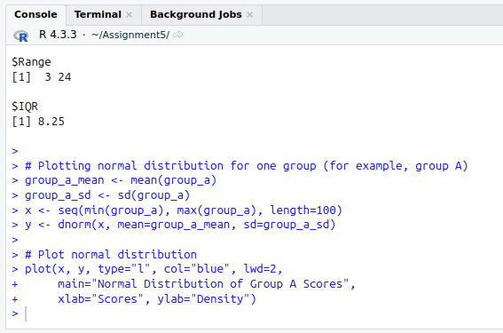

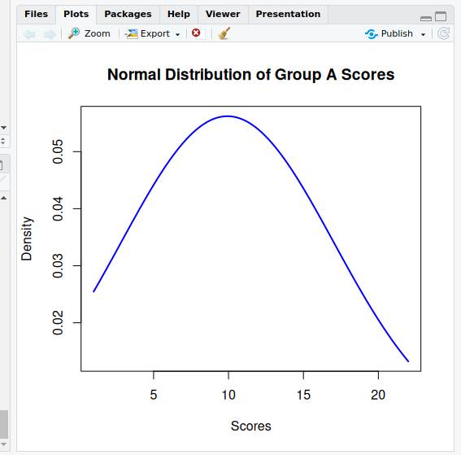

**Q.2) Plot the line graph using v&lt;- c(7,12,28,3,41) and save the plot.**

**Answer:-**

# Define the vector v

v <- c(7, 12, 28, 3, 41)

# Display the line graph in the IDE

plot(v, type = "o", col = "blue", xlab = "Index", ylab = "Values",

main = "Line Graph of v")

# Save the line graph as a PNG file

png("line_graph_v.png") # Open a PNG device to save the plot

plot(v, type = "o", col = "blue", xlab = "Index", ylab = "Values",

main = "Line Graph of v")

dev.off() # Close the PNG device to save the file

**Output:-**

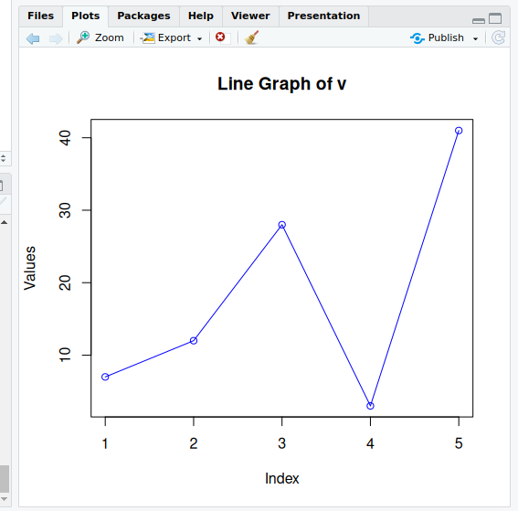

**Q.3) Read the file moviesData.csv create a bar chart of critics_score for the first 10 movies.**

**Save the plot.**

**Answer:-**

# Load necessary libraries

library(ggplot2)

# Read the CSV file

movies_data <- read.csv("moviesData.csv")

# Check the structure of the data to ensure it contains 'critics_score'

str(movies_data)

# Extract the first 10 rows and relevant columns

first_10_movies <- movies_data[1:10, c("title", "critics_score")]

# Create a bar chart using ggplot2

bar_chart <- ggplot(first_10_movies, aes(x = reorder(title, -critics_score), y = critics_score)) +

geom_bar(stat = "identity", fill = "blue") +

labs(title = "Critics Score for the First 10 Movies",

x = "Movie Title",

y = "Critics Score") +

theme(axis.text.x = element_text(angle = 45, hjust = 1))

# Display the bar chart

print(bar_chart)

# Save the plot as a PNG file

ggsave("critics_score_bar_chart.png", plot = bar_chart)

**Output:-**

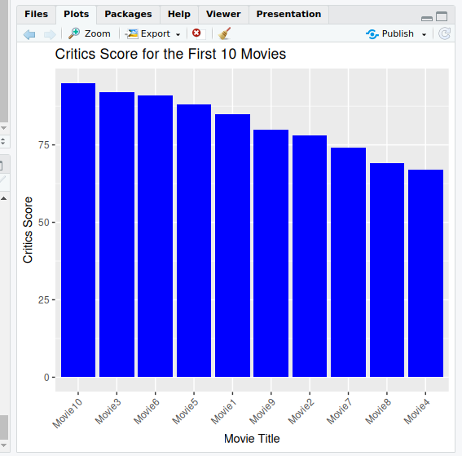

**Q.4) Create a scatterplot of imdb_rating and imdb_num_votes to see their relation and save**

**the plot.**

**Answer:-**

# Load the necessary library

library(ggplot2)

# Read the CSV file (ensure moviesData.csv is in your working directory)

movies_data <- read.csv("moviesData1.csv")

# Create a scatterplot of imdb_rating vs imdb_num_votes

scatter_plot <- ggplot(movies_data, aes(x = imdb_num_votes, y = imdb_rating)) +

geom_point(color = "blue") + # Scatter plot points in blue

labs(title = "Scatterplot of IMDb Rating vs Number of IMDb Votes",

x = "IMDb Number of Votes",

y = "IMDb Rating") +

theme_minimal() # Applying a clean theme

# Display the scatterplot

print(scatter_plot)

# Save the scatterplot as a PNG file

ggsave("imdb_scatterplot.png", plot = scatter_plot)

**Output:-**

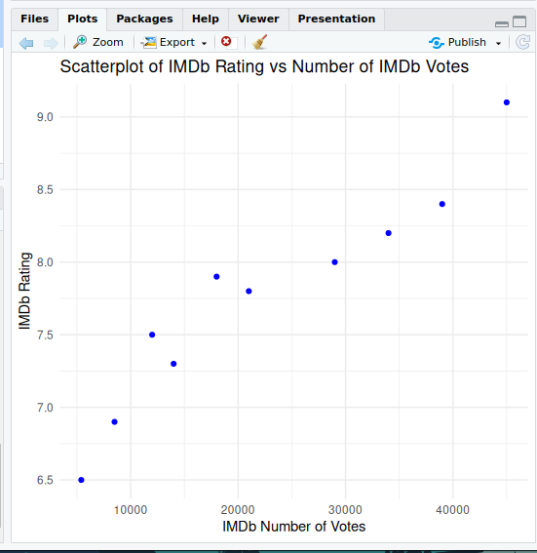

**Q. 5) Use the data set “mtcars”and create a boxplot for “mpg” and “cyl” columns.**

**Answer:-**

# Load the necessary library

library(ggplot2)

# Use the built-in mtcars dataset

data("mtcars")

# Create a boxplot of mpg (Miles per Gallon) grouped by cyl (Number of Cylinders)

boxplot <- ggplot(mtcars, aes(x = factor(cyl), y = mpg)) +

geom_boxplot(fill = "lightblue") +

labs(title = "Boxplot of MPG by Number of Cylinders",

x = "Number of Cylinders",

y = "Miles per Gallon (MPG)") +

theme_minimal()

# Display the boxplot

print(boxplot)

# Save the boxplot as a PNG file

ggsave("mpg_cyl_boxplot.png", plot = boxplot)

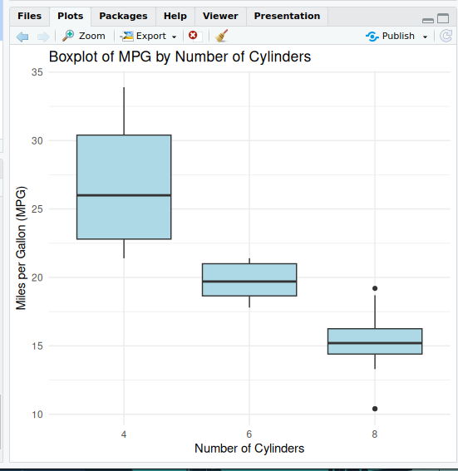

**Output:-**

**Q.6) Read the file movies Data.csv, create a histogram of the object named imdb_num_votes**

**in this file. Save the plot.**

**Answer:-**

# Load the necessary library

library(ggplot2)

# Read the CSV file (make sure the file is in your working directory)

movies_data <- read.csv("moviesData1.csv")

# Check the structure to ensure imdb_num_votes is present

str(movies_data)

# Create a histogram of imdb_num_votes

histogram <- ggplot(movies_data, aes(x = imdb_num_votes)) +

geom_histogram(binwidth = 1000, fill = "lightblue", color = "black") +

labs(title = "Histogram of IMDb Number of Votes",

x = "Number of IMDb Votes",

y = "Frequency") +

theme_minimal()

# Display the histogram

print(histogram)

# Save the histogram plot as a PNG file

ggsave("imdb_num_votes_histogram.png", plot = histogram)

**Output:-**

